**Code Documentation: Assignment#3**

Downloaded the dataset from the GitHub link provided [here](https://raw.githubusercontent.com/resbaz/r-novice-gapminder-files/master/data/gapminder-FiveYearData.csv) to solve the problem given. The dataset consists of six columns namely: **country, year, pop, continent, lifeExp and gdpPercap**.

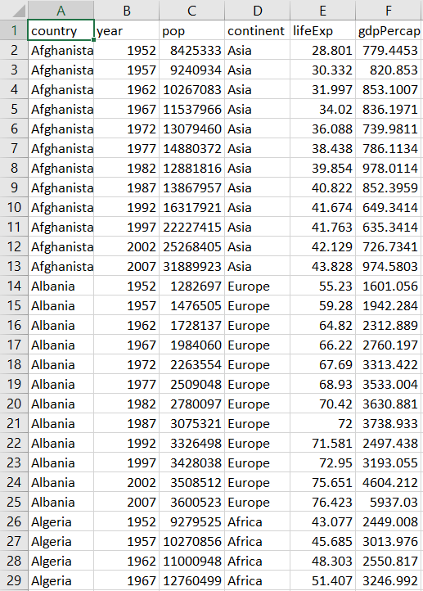

Importing the libraries (pandas, numpy, matplotlib.pyplt and seaborn) which will be used in the code as the first step.

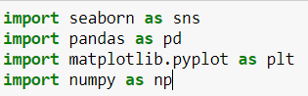

The next step is to create a DataFrame df by exporting the csv file to Jupyter notebook using the **read_csv()** method present in the pandas library. Later, we print the first five rows of the DataFrame df using the **head()** function.

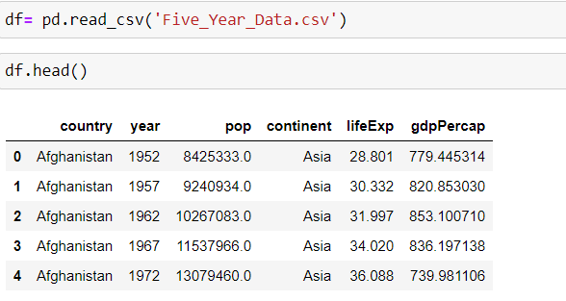

According to the problem statement, we are supposed to create a pivot table dataframe with **year** along x-axis, **country** along y-axis and **lifeExp** filled within cells.



The above code creates a new DataFrame named df2 which is the pivot table satisfying the conditions of the given problem statement. The pivot table in DataFrame df2 contains 142 rows (countries) and 12 columns (years).

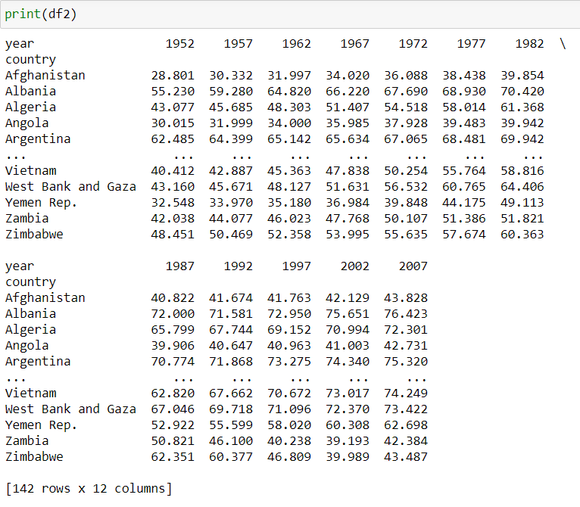

The next step of the problem statement is to plot a **HeatMap** using **seaborn** library for the pivot table that was just created. The values (lifeExp) present in the DataFrame df2 conatins float values. While plotting the HeatMap along with annotation, the HeatMap created will be unreadable. Therefore, we convert the float values to integer values in the following code:

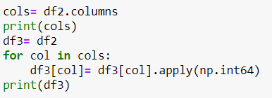

Now we have converted the float values to integer column-wise and saved it in a new DataFrame named df3.

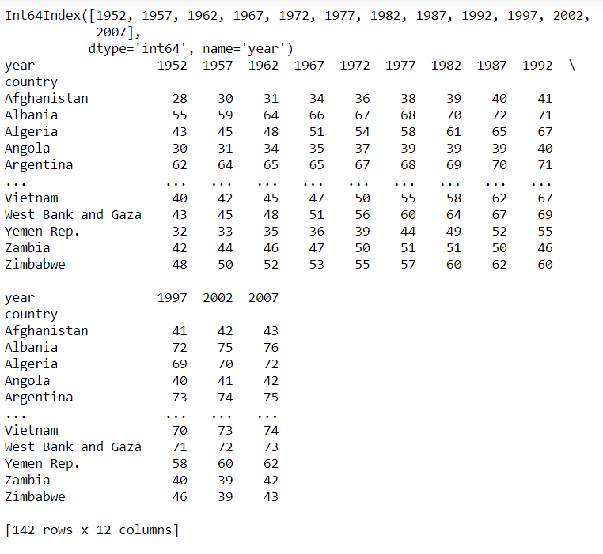

As the last step of the code, we create a Heatmap using year as x-axis and country as y-axis. We resize the created plot using the **plt.subplots()** method and specify the figure size using the **figsize** parameter. Then DataFrame df3 is plotted in a HeatMap along with **annot** parameter to display the values in the Plot and **fmt** parameter is assigned to **‘d’** which denoted integer type. The figure the displayed using the **get_figure()** method and the displayed figure is saved locally as **“Assignment_output.png”** using **savefig()** method.



The Assignment_output.png is as follows which is the output HeatMap that is required from the Problem Statement:

